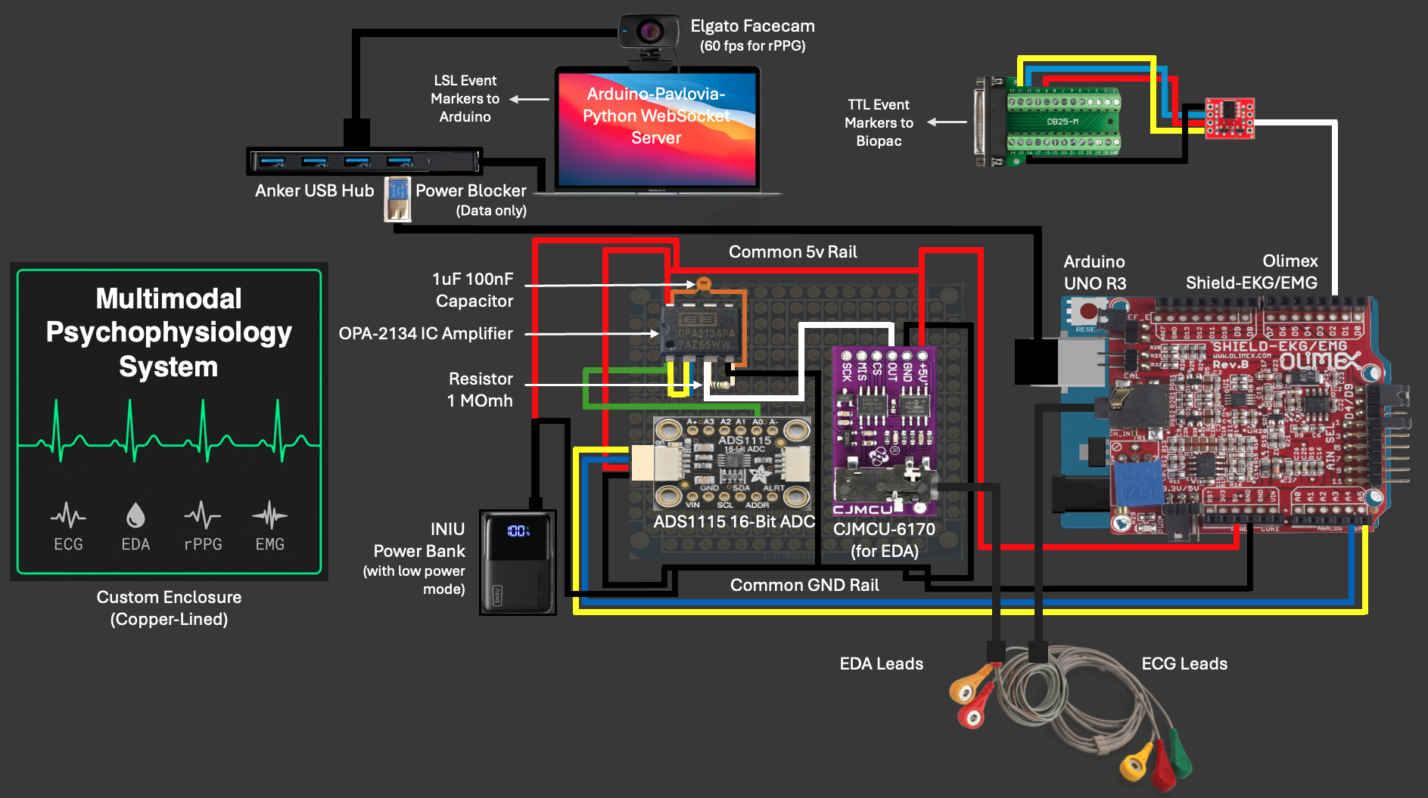
Figure X. Open Source Multimodal Psychophysiology System.

